***ASSIGNMENT-1***

1. ***Explain what is Xcode?***

***Answer-*** xcode is an IDE for macOS developed by apple for developing the application software for macOS,iOS,iPadOS.

1. ***Explain how you can add frameworks in Xcode project?***

***Answer-***  Initially we have to create a framework in iOS template and then we have to drag the the framework folder under the project folder and then we can use it.

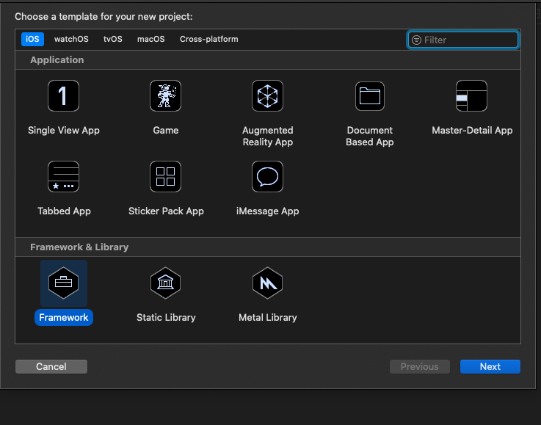

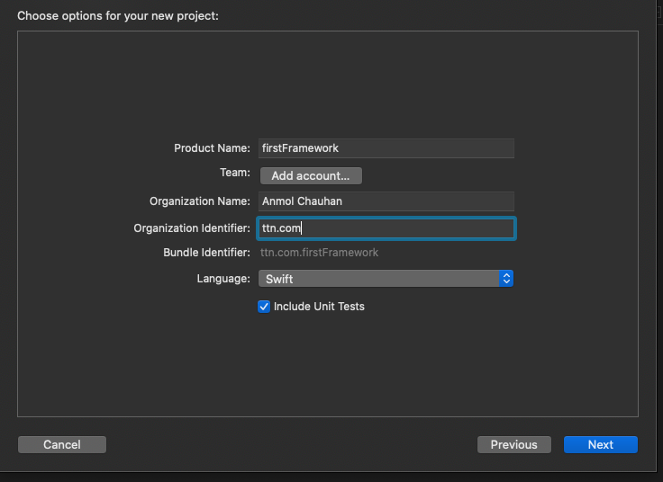

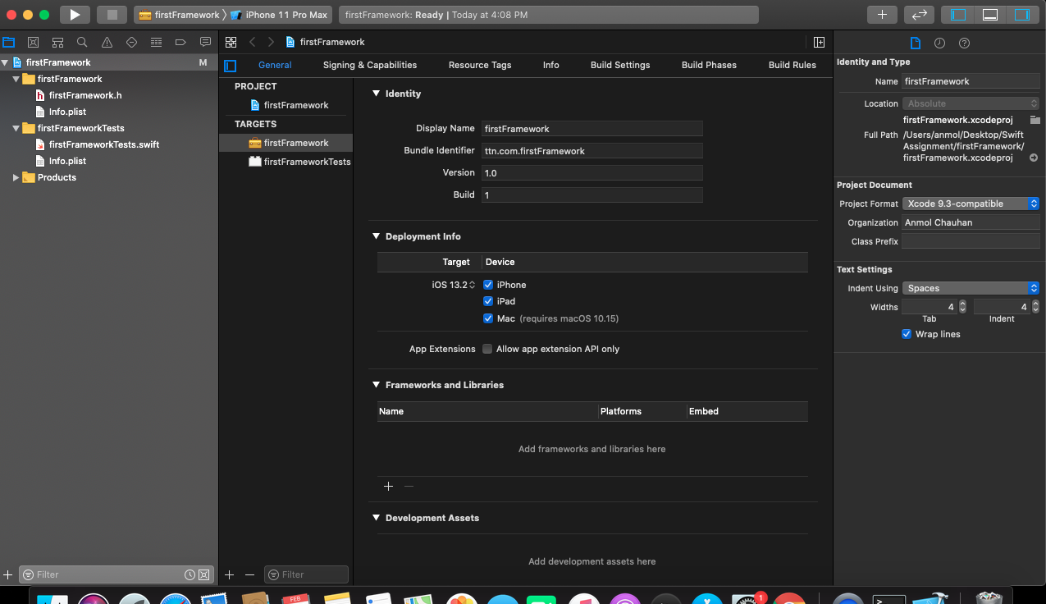

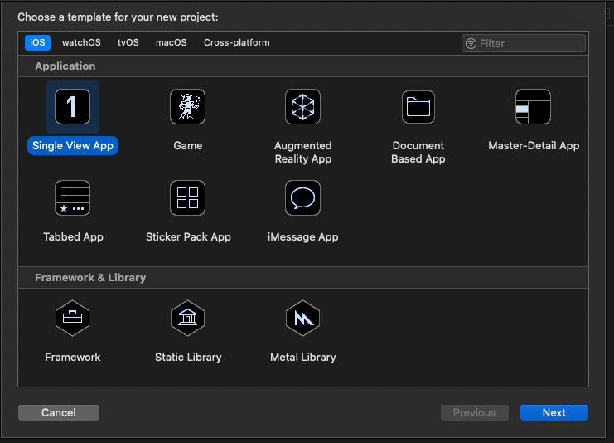

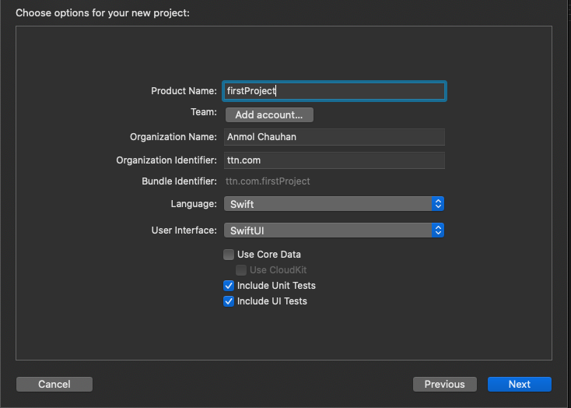

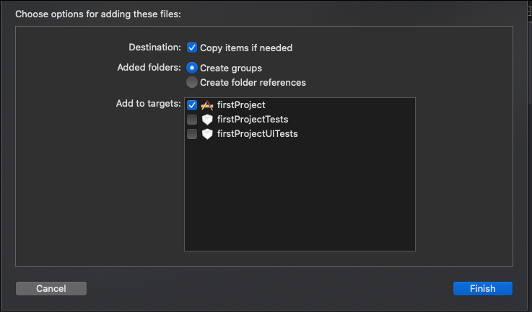

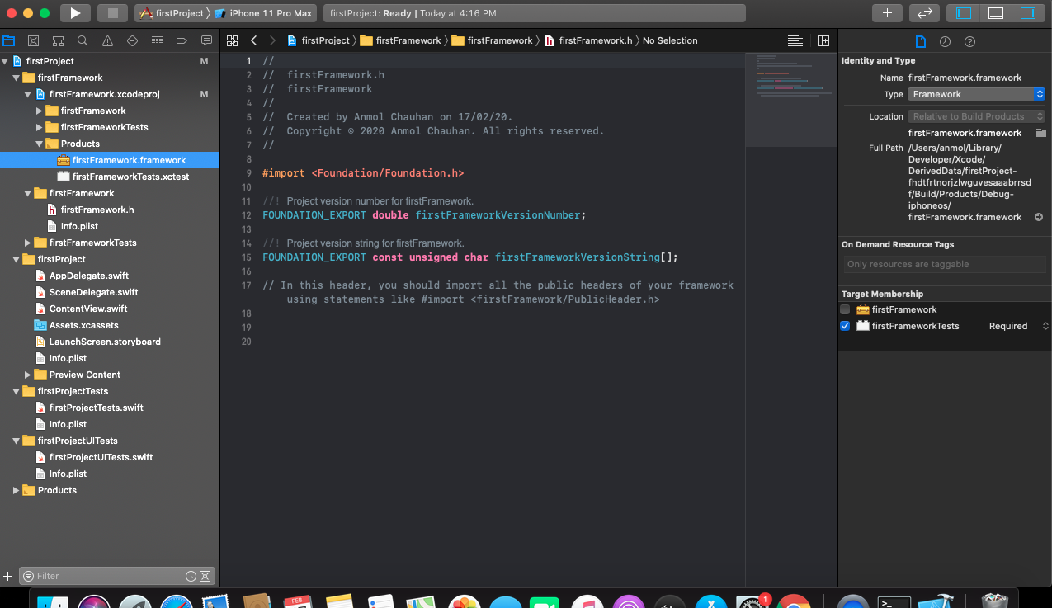

1. ***Explain what is the difference between Xcode, Cocoa and Objective C?***

***Answer-***

***xcode-*** xcode is an IDE for macOS developed by apple for developing the application software for macOS,iOS,iPadOS.

***Objective-C -*** Objective C is an object oriented programming language, it was originally developed in the early 1980s. Before the introduction of Swift language, objective is the main language for the application development of macOS,iOS

***COCOA*** - Cocoa is a framework that provides the prebuilt classes that are used to build the application in macOS,iOS.

1. ***What is the short cut to open the “Code Snippet Library” in Xcode?***

***Answer-***  Shift+command+L

1. ***Mention what are the build phases available in Xcode?***

***Answer-***  Build Phases in xcode are:-

1. Dependencies

2. Compiler sources

3. Link Binary with Libraries

4. Copy Bundle Resources

1. ***Explain how app delegate is declared by Xcode project templates?***

***Answer-***  App delegate is an object that interacts with the other object to when it reaches a certain state in the life cycle of an app.

Some function that work in the app life cycle are:-

(i) didFinishLaunchingWithOptions

(ii) configurationForConnecting

(iii) didDiscardsceneSessions

1. ***Explain how you define variables in Swift language?***

***Answer-*** We can declare the variable in swift language by using the “var” keyword.

For ex…. var variableName = variableValue

var name = “Akash”

Here the variable name is “name” which is having the String type of value “Akash”.

1. ***What is interface builder?***

***Answer-***  Interface builder is the editor on the xcode on which the application interface design.

1. ***Create an app with a login interface which should have two text field for email, password where the password is a secure field and a button.***

***Answer-***  application files are uploaded on git in the secondProject file.

1. ***List devices and their resolutions, screen size has iOS as their OS.***

***Answer-***

1. iPhone 4,4s -- 640 X 960- 3.5”
2. iPhone 5s, 5c, 5, SE -- 640 X 1136- 4”
3. iPhone 8,7,6s,6 -- 750 X 1334 - 4.7”
4. iPhone 8+, 6+,6s+, 7+ -- 1242 X 2208 - 5.5”
5. iPhone 11,XR - 828 X 1792 -- 6.1”
6. iPhone 11 pro,X,XS -- 1125 X 2436 - 5,8”
7. iPhone 11 pro max,XS max -- 1242 X 2688 - 6.5”
8. iPad Air -- 1536 x 2048 - 9.7”
9. iPad Pro -- 2048 x 2732 - 12.9”
10. iPad pro -- 1668 x 2388 - 11”
11. iPad pro(1st gen) -- 1668 x 2224 - 10.5”
12. iPad mini -- 1536 x 2048 - 7.9